URBANA VOLUNTEER FIRE AND RESCUE
SPORTSMAN’S RAFFLE
SATURDAY OCTOBER 15, 2022
Doors Open 4:30pm
$35.00 Donation includes Meal & 1 Guest
Doors open 4:30
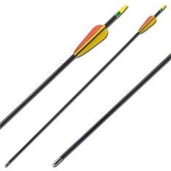
Make checks payable to: UVFD Mail to: UVFD
C/o Donna Houck or Cheryl Hipkins
3602 Urbana Pike
Frederick MD 21704

Contact: Call or text Donna at (240)440-8124 for tickets or additional information
Cheryl Hipkins at Cherylhipkins@gmail.com

